2/2/2020

Project Assignment 3

Fahrenheit 451

OSKAR CIEBIEN - STUDENT

G00369579

Table of Contents

**Features & User Story identification and creation** 2

**Features** 2

**User Stories** 2

**User Story sizing** 3

**User Story definitions of READY and DONE** 4

**READY** 4

***DONE*** 4

**Team Working Agreement** 5

# **Features & User Story identification and creation**

## **Features**

* Multiple game review posts.
* Forums section for users to state their own opinions and to connect with each other.
* Easy to use User Interface.

## **User Stories**

* As a software engineer, I want the code to be well commented so that it will be easy to read and upgrade the website. **(Oskar)**
* As a software engineer, I want to correctly implement so that the final program can run as smooth and efficiently as possible. **(Oisin)**
* As a tester, I want to make sure all code is working correctly and to find any bugs that may occur.**(Mark)**
* As a product owner, I want my team to be organized and prepared for the work that needs to be done to complete the project. **(Connor)**
* As a scrum master, I want to make sure that the team knows what to work on and to make it as easy as possible for them. **(Pasha)**

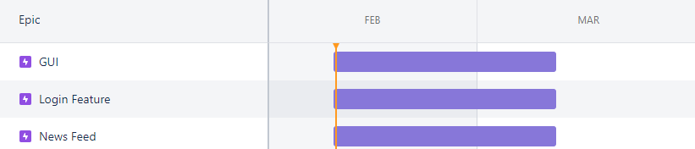

We used our Jira project site to create timelines for our features. This way we won’t lose track of our work and our developers will know what they should focus on first.

# **User Story sizing**

**1**

UI

**1**

Login Feature (Account)

**2**

Good Graphics

**3**

News Feed (Refreshed)

**5**

Honest Reviews

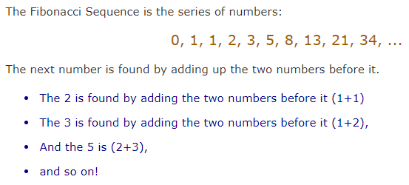We have used Fibonacci Sequence for story sizing.

We used this sequence to help us sort our User Story Sizing.

Link:

<https://www.mathsisfun.com/numbers/fibonacci-sequence.html>

# **User Story definitions of READY and DONE**

## **READY**

*User Story definition of READY describes the things that have to be ready before the team can start working on the tasks*.

* Sprint accepted
* Able to be worked on by the team

## ***DONE***

*User Story definition of DONE is a list of user stories that require the team to call it complete.*

* When the user story achieves the outline requirements during the READY stage.
* When it can be sold back to the buyer as a working model.

# **Team Working Agreement**

*Good communication*

*Cooperate with other team members*

*Come to meetings*

*Be organized*

*Not being late*

*Stay friendly and respectful*

*Stay honest*

*State your own opinions*

During the lab, we have decided on the agreement as a team of three. Few of us were missing, but they agreed on it later when we posted it on OneNote.